OREGON INSTITUTE OF TECHNOLOGY
Computer Systems Engineering Technology Department
CST 315 – Embedded Sensor Interfacing I/O
Lab 4 – Linear Power Supply
Name: Chris Thomas
Justin Brumble Score: ____________
PURPOSE:
The purpose of this lab is to study the operation of linear power supplies. The relationship between the size of the smoothing capacitor, the load resistance and the ripple voltage will be investigated. The use of a 7805 Voltage Regulator and a Buck Converter are demonstrated.
EQUIPMENT AND SUPPLIES:
- Oscilloscope with probes
- DMM with probes
- Step down transformer
- 1 – diode 1N4007
- 1 – 2.2K resistor
- 1 –100 Ohm, Power resistor
- 1 – 1000 uF, 63 V electrolytic capacitor
- 1 – 7805 Voltage Regulator
- 1 – Buck Converter

PROCEDURES:
Before Applying Power to ANY of the Circuits in This Lab You Must Obtain the Instructor’s Permission. If You Do Not You Will Get a ZERO for your Lab Grade.
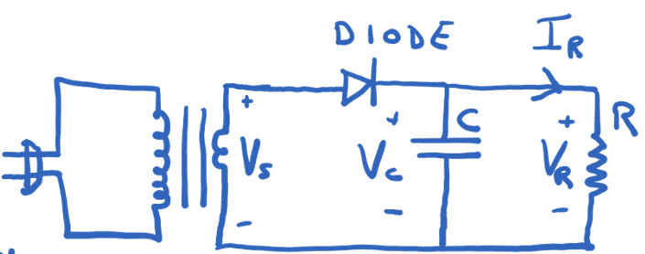

Transformer’s Secondary Voltage Rating Vs = 9VAC (rms)
Frequency = 60 Hz

- Build the circuit shown above with the capacitor C = 1000 uF and the resistor R = 2.2K. Have the Instructor approve the circuit before plugging the stepdown transformer into the wall outlet.

Use the scope to observe and measure the voltage of the transformer’s secondary.
What is the shape of the secondary’s voltage?___________sin wave______________
What is the peak voltage of the secondary’s voltage?________16.3V___________

Use the scope to measure and record the ripple voltage across the capacitor.
Measured Vripple = ____120mV______

Measure and record the peak voltage across the capacitor with the scope.0
Measured Vcmax = _____60mV_____

Unplug the stepdown transformer.

- Rebuild the circuit shown above with the 100 Ohm Power in the place of the 2.2K resistor. Have the Instructor approve the circuit before plugging the stepdown transformer into the wall outlet. The 100 Ohm resistor will get WARM!

Use the scope to measure and record the ripple voltage across the capacitor.
Measured Vripple = ____2.0V_______

Measure and record the peak voltage across the capacitor with the scope.
Measured Vcmax = _____1.0V_______

Unplug the stepdown transformer.

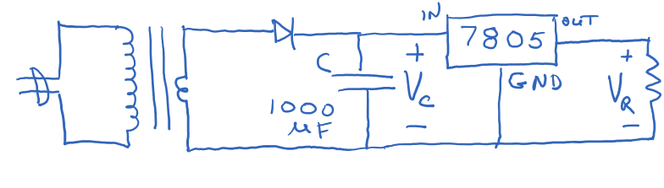
- Build the circuit shown above with the capacitor C = 1000 uF and the resistor R = 100 Ohms power resistor. Insert the 7805 Voltage Regulator in between the capacitor and resistor of the previous circuit (pinout of 7805 shown at the end of this Lab Handout). Have the Instructor approve the circuit before plugging the stepdown transformer into the wall outlet. Work carefully and quickly. The 100 Ohm resistor and the 7805 regulator will get WARM!

Use the scope to measure the ripple voltage across the 1000 uF capacitor. Record the value. How does your measured value compare to the measured value of the ripple voltage in step 2?

Step 3 Measured Vripple = ____868mV____ Step 2 Measured Vripple = 120mV

Measure and record the peak voltage across the capacitor.
Measured Vcmax = _______434mV______

Measure and record the ripple voltage across the 100 Ohm resistor.
V _{ripple 100 Ohm resistor} = ______0________

Using your DMM measure and record the current and voltage at the input of the
7805 Voltage Regulator.
Current = _______54.38mA_____; Voltage = ____14.1V_______

Using your DMM measure and record the current and voltage out of the 7805 Voltage
Regulator.
Current = ____50.5mA________; Voltage = ____5.05V________

Calculate the Power Into the Voltage Regulator and the Power Out of the Voltage
Regulator.

Power Into Voltage Regulator = _____766.758mW______ (Pin = Iin * Vin)

Power Out of Voltage Regulator = _255.075mW________ (Pout = Iout * Vout)

Calculate the efficiency (in percent) of the 7805 Voltage Regulator.
Efficiency = _____33.27%______ Efficiency(%) = (Pout/Pin) * 100%

Unplug the stepdown transformer.

- Replace the 7805 Voltage Regulator with the Buck Converter as shown below. The capacitor (1000uF) and the resistor (100 Ohm) values are the same as in step 3.
Power up the circuit after you are finished building it.

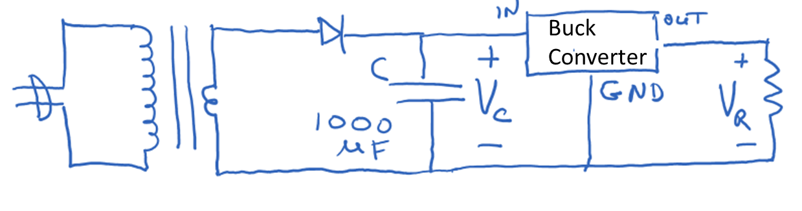
Adjust Buck Converter’s potentiometer until the output voltage is 5V as measured by the
DMM. Measure and record the current out of the Buck Converter with the DMM.
Current = _____49.84mA______.

Measure the input voltage and current of the Buck Converter with the DMM.
Current = ____29.02mA_______; Voltage = _____14.58V______

Calculate the Power Into the Buck Converter and the Power Out of the Buck Converter.

Power Into Buck Converter = _____423.112mW______ (Pin = Iin * Vin)

Power Out of Buck Converter = ____249.2mW______ (Pout = Iout * Vout)

Calculate the efficiency (in percent) of the 7805 Voltage Regulator.
Efficiency = ____58.89%_______ Efficiency(%) = (Pout/Pin) * 100%

Using the scope measure the peak to peak noise out of the Buck Converter as well as the
frequency of the noise. Use AC coupling on the scope to measure the noise in the output voltage of the Buck Converter. AC coupling will block the DC portion of the Buck Converter’s output voltage and pass only the AC portion to the scope.
Noise Voltage = ____126mV______; Frequency = ____55.52kHz_______

Top View of 7805 Voltage Regulator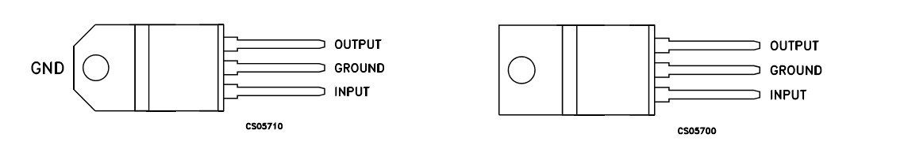

Top / Bottom Views of the Buck Converter- Input 3VDC to 40VDC; Output 1.5VDC to 35 VDC (See next page for bottom view)
